Software Requirements Specification
For
Support Tickets Database Manager
Version 1.03 approved
Prepared by Ilan Kroter,Stav Lobel,Ivan Rubinson,Alon Gabay ,Ilan Tulepov,Lidor Zaguri,Itay Halaf,Ron Shokoury.
Group 3
30/10/2018
Table of Contents
Table of Contents ii
Revision History ii
1. Introduction 1
1.1 Purpose 1
1.2 Document Conventions 1
1.3 Intended Audience and Reading Suggestions 1
1.4 Product Scope 1
1.5 References 1
2. Overall Description 2
2.1 Product Perspective 2
2.2 Product Functions 2
2.3 User Classes and Characteristics 2
2.4 Operating Environment 2
2.5 Design and Implementation Constraints 2
2.6 User Documentation 2
2.7 Assumptions and Dependencies 3
3. External Interface Requirements 3
3.1 User Interfaces 3
3.2 Hardware Interfaces 3
3.3 Software Interfaces 3
3.4 Communications Interfaces 3
4. System Features 4
4.1 System Feature 1 4
4.2 System Feature 2 (and so on) 4
5. Other Nonfunctional Requirements 4
5.1 Performance Requirements 4
5.2 Safety Requirements 5
5.3 Security Requirements 5
5.4 Software Quality Attributes 5
5.5 Business Rules 5
6. Other Requirements 5
Appendix A: Glossary 5
Appendix B: Analysis Models 5
Appendix C: To Be Determined List 6

Revision History
Name | Date | Reason For Changes | Version
Ilan,Ivan,Lidor | 29.10.18 | Minor Fixes | 1.01
Ilan Kroter | 30.10.18 | Minor Fixes | 1.02
Ilan Kroter | 20.11.18 | Fixes-Severity and reporting system for the sake of analysis | 1.03
Stav Lobel | 12.12.18 | Added openSSL info .

Introduction
  - Purpose
In many organizations which have a technical support department, there needs to be a management and control system that could handle the vast information of many technical problems they are in charge of, this system is rooted on the company workers and their ability to use this kind of information to solve their problems in the best possible way.

Why?
When a company grows, the volume of issues increases. The existing mechanisms wear down, and if there's no order in the documentation and solutions, there can be chaos. In addition when there are a lot of unresolved problems, new problems may rise additionally.
When the volume of information is high, human error may occur, and issues may mistakenly go unresolved, or the service quality is lowered. When more issues on similar subjects happen again and again in the world of I.T they tend to repeat unless tracked.

Solution:
Software system for the management of technical support tickets, which will serve the users, and optimize the existing mechanisms, as well as helping to track problems that repeat themselves several times.
In addition, the system offers high-level overview dashboards, which manual systems do not.

  - Document Conventions
There are no special conventions in this document.
  - Intended Audience and Reading Suggestions
For Group 3 Developers and “Software Engineering Basics” Teachers.
  - Product Scope
Software system for the management of technical support tickets, which will serve the users, and optimize the existing mechanisms.
In addition, the system offers high-level overview dashboards, which manual systems do not.
  - References
Initial Document (on moodle)
- Overall Description
  - Product Perspective
In many organizations which have a technical support department, there needs to be a management and control system that could handle the vast information of many technical problems they are in charge of, this system is rooted on the company workers and their ability to use this kind of information to solve their problems in the best possible way.
  - Product Functions
- Create service call
- Read tickets
- Update tickets
- View, sort, filter all tickets
- Receive statistics about the tickets

Supporting functions:
- Log-in & authentication
Allows joining tickets to specific customers (see definition of customer) and accessing management functionalities for support givers.
  - User Classes and Characteristics
The system would work with the following kinds of users:
- The customer- A worker in the company whom faced a technical problem in the companies' apps or any standard computer problems.
- Help desk – The first level for facing a problem. The helpdesk team tries to handle the problem first on their level, trying simple tasks or known repairs on their field (those that don't require the person to arrive at the spot or do lengthy repairs). They also should handle the service calls that the customer opened.
- Technicians- They handle all the cases the helpdesk can't handle due to experience, the need to arrive at the worker's place, or due to time management.
- Engineers - When a problem is more severe and needs a review of the system the problem is present on, they should be the ones that can solve the problem most of the time.
- Technical leader - The person in charge of a team of support givers.

  - Operating Environment
OS
The system is expected to work on Microsoft Windows 7 or later.

System requirements
Processor: Pentium III or higher
Keyboard: present
Ram: 1024 MB ram or more.
Storage: 10 GB
Database: Files - txt.

  - Design and Implementation Constraints
Constraints
- Memory & other hardware limits of said machine

Assumptions:
- Support givers can access & operate the computer
- Users can access & operate said computer, or contact someone who can (e.g. phone call to support giver)
- Data integrity & back-ups are not managed by this system
- Every user of the system is a member of the company and has a user name and password to access the system.
  - User Documentation
Not written documentation, if needed a tour of the system will be given to support givers.
  - Assumptions and Dependencies
Required to use openSSL.
- External Interface Requirements
  - User Interfaces
A representation of the program is included in an attached file.
  - Hardware Interfaces
Keyboard and screen.
  - Software Interfaces
Connected to the organization human resources that contains the data of the workers, and their users ,also used openSSL
  - Communications Interfaces
The system works offline, only a single computer can access the system, and the database is manually updated.
- System Features
User class – The customer:
Customer can create new service call, via the system’s self-service, providing information like
- Type
- Title
- Severity
- Detailed description
- Tags
Customer can also view (read-only) the tickets that they opened.

User class – The support giver
Support giver can create new tickets, providing initial information like:
- Type
- Severity; severity levels are: Medium, High, Urgent, Critical (See definitions)
- Media of Communication: self-service, phone call, E-Mail, frontal contact.
- Title
- Description
Support giver can edit existing tickets:
- Add notes
- Change status (like close the ticket); status levels are: new, in-progress, closed.
- Escalate
- Change stakeholders
Support giver can list tickets by various filtering criteria; for example, by customer, thus viewing their ticket history.

User class – The technical leader
Can do everything a service giver of the same tier can.
The listing and filtering of tickets is a tool that provides the leader with insight in to the effectiveness of their support givers, and the general health of the supported systems.
See definition - Supported Systems.

The technical leader job is also to view all the tickets and analyze patterns, there is in the system a function of gathering statistics in from the system so he can gather information about the state of different issues that appear in the company, as well as having a way to track recurring issues and trends in the system.
  - Features
Detailed above.

- Other Nonfunctional Requirements
  - Performance Requirements
The system performance will take up to 5 seconds for each operation.
  - Safety Requirements
The access to the program needs to be restricted only to the company workers and support givers so the data of the workers doesn’t leak to outsiders, the files of the program need to be saved in a way that they can’t be easily accessed so they aren’t compromised.
  - Security Requirements
There’s a login system in the program, only workers of the company may login to the system and create a service call.
  - Software Quality Attributes
The system is very quick, stable and minimalist and it’s very straight forward in terms of ease of use.
  - Business Rules
Not relevant - the system is not part of the business module.
- Other Requirements
Not relevant - no other requirements.
Appendix A: Glossary
Ticket types / supported systems: anything that is technical

Management view -
The mode of the system that allows service call handling, it's meant for the technical support division of the company.

Self-Service:
The system that is available to the none-support giver to open tickets, it sends the tickets to the support givers (see definition).

Service Call -
A service call (or ticket) is a problem definition that is used for sorting the problems into a more organized form to handle them better, including the person or team in charge of handling the problem, and all additional data that can help solving the problem.

Service Givers -
Members of the workers that handle problems in the system include: helpdesk, technicians, and engineers.

Severity Levels:

There are several Severity levels:
1. Medium- it’s an issue that affects a small amount of users or have an easy workaround.
2. High- System performance issue or bug affecting some, but not all users, there’s a short term workaround.
3. Urgent- Large scale issue affecting a large amount of users impeding functionality, there’s no reasonable workaround.
4. Critical-Critical production issue affecting all users, there’s no workaround available and includes system unavailability

Support Tiers:

There are several levels of treatments to a service call (see definition) that go by the skill that every type of support giver has.
The standard tiers in this software are of the following order:
Helpdesk, technicians, engineers and the technical leader which is a part of each team and is in charge of more complicated matters on each level/tier.

User -
The user is a worker in the company.
Appendix B: Analysis Models
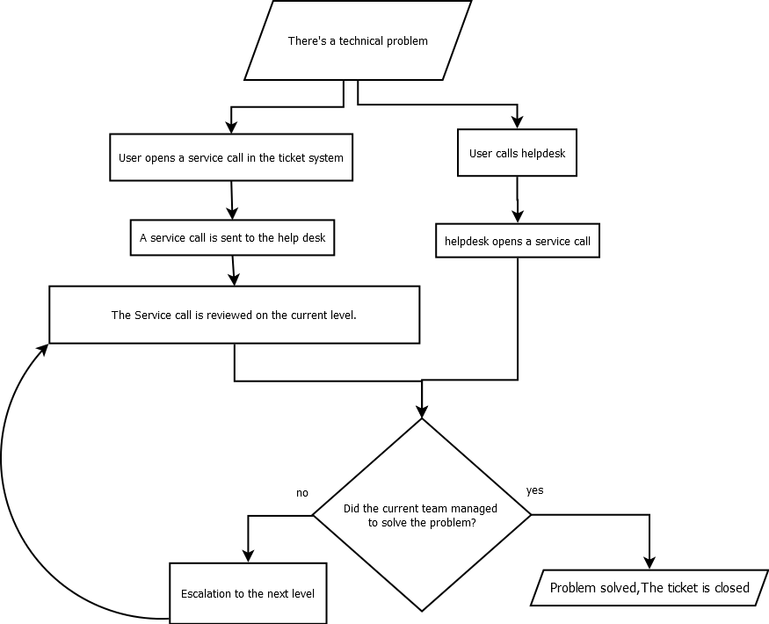

Overview:
The process of problem solving using this system, starts with the user facing a problem –
He can either decide to use either the system's self-service (most common problems and their solutions) or call the helpdesk; in both cases the service givers attempt to help the user and if they manage to solve it, the case is closed at the helpdesk level, otherwise the ticket is escalated to the next tier. The problem may be escalated further until the problem is solved.

Appendix C: To Be Determined List
not relevant.

